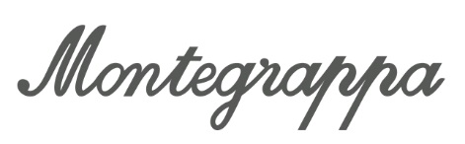

PENS AGAINST PARKINSON’S DISEASE

A new artist-collaboration pen features a pocket clip shaped like a tulip to raise awareness and support for Parkinson’s disease research.

A remarkable new prestige pen by Montegrappa has been designed to draw attention to the plight of those living with Parkinson’s disease, a degenerative neurological disorder estimated to affect more than six million people around the world. Available from today, the Tulip for Team Fox enables pen owners to show solidarity with Parkinson’s patients, while helping The Michael J. Fox Foundation for Parkinson’s Research (MJFF) accelerate research into a cure.

The pen’s striking clip is a reference to the international symbol of Parkinson’s consciousness – the red tulip. Its design comes from an idea and sketches from Timothy John – a fine artist from Adelaide, Australia. The passionate fountain pen user was himself diagnosed with Parkinson’s in 2017, and his initiative to alleviate the suffering of others counts among John’s most personal and transformative projects.

Ten percent of proceeds from sales of the Tulip for Team Fox will be donated to MJFF. The world’s largest non-profit funder of Parkinson’s disease research has funded more than $800 million since its inception in 2000. Its results moved Bloomberg to describe it recently as “the fulcrum on which Parkinson’s research pivots.”

For Montegrappa C.E.O. and Creative Director Giuseppe Aquila the new, Solidarity Edition pens offer a chance to do good on both a broad and personal level. “Timothy has been a regular collaborator with us over many years and we were deeply impacted by the news of his diagnosis. For us, this is a rare opportunity to raise awareness and express fraternity with a dear friend,” Aquila explains. “We are honoured to be able to donate a portion of proceeds to The Michael J. Fox Foundation.”

The brand has previously been involved with fundraising for Parkinson’s through its partnership with the late Muhammad Ali and his Celebrity Fight Night auctions.

As makers of luxury writing instruments, Montegrappa approaches every design from the perspective of a jeweller. When stowed in a pocket, a pen’s clip functions like a pin or brooch, with the difference that it is an implement used every day. It is hoped that this heightened functionality – and the intimate relationship between writer and pen – can create a more resonant awareness of a pressing social issue.

Handmade in Italy, the Tulip for Team Fox is available in fountain pen, rollerball and ballpoint modes from fine writing boutiques and montegrappa.com from € 275,00 ($ 330,00).

